The Benefits of Crawling
Blog post for The Chiropractic Centre Bristol by Helena Read July 2016

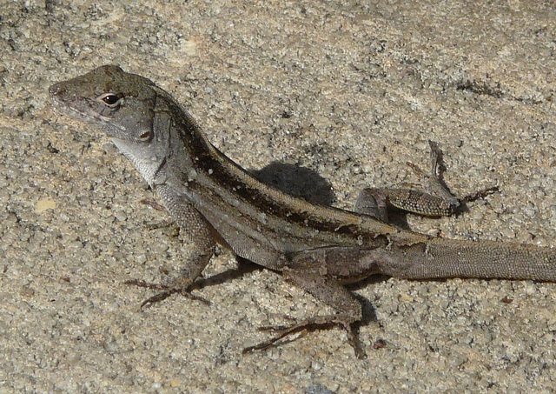
Photo: Greg Goebel 2008
https://www.flickr.com/photos/37467370@N08/7687654564/in/photolist-cHkeSm-CnvY35-ezThSr-9sjhni-6vtTd9-a1xEZg-63TEDU-q1yFKS-ccnUYQ-nLbs6W-6VNYD2-6eCfF9-cGGFtU-fBa1EG-96p3wo-FAdTr-h43xkv-L1zK-nMRjmY-cjnv5E-op9RkL-HU8qUS-9z51Eh-9A7x9S-9X2Vat-deghFa-h43KGJ-afLuKV-ocG9Cf-8wccyd-f9zn9x-9snfGS-ccnV23-9ACPHG-ccnV4d-9trTac-6wRnEt-8qUFhx-aaSdim-6gejnb-axDYbc-7VHePr-fCqQuw-rWSsmn-7ZQtaq-5iaiV-bXuciC-nAowfP-oR1B8A-kQskbB
(Charlie, please credit the photographer and add the above link to his name for Creative Commons use license)

My fascination with crawling began when my first-born began to roll, reach, stretch and find his own way to movement on all fours. As a dancer and massage therapist I could scarce pull my eyes away from this miracle of movement unfolding in front of my eyes.

The dynamic combination of determination, push and yield that I witnessed running throughout his whole body has fueled my own exploration of crawling, and an ongoing inquiry to its wellbeing benefits. In this article I will share some of my passion for this simple and profoundly effective method for regaining original strength, as well as a little of the science.

A baby’s determination to crawl is initiated by 4 billion years of human evolution coupled with profound curiosity. In the case of my son, this curiosity often took the form of our cat, though anything that lay in easy eyesight and just out of reach would do, even simply a patch of light playing on the floor.

This movement of reach is made possible by the dynamic force of push that comes from an opposite limb, often on the diagonal, sometimes on the same side of the body. The push and pull would start with the extremity of toes, fingers, elbows or knees gaining traction on the surface beneath them, and lead to a rocking movement that would gradually provide the momentum for progress towards the said attractive object.

Integral to this push is a movement of yield, when the opposing muscles soften, allowing the spine to arch and become a spring of rocking movement, which steadily increases in size and energy until a limb is successfully moved and the body balance changes.

Watching my son as he mastered the art of movement I realised that our whole bodies are a dynamic, elastic coil of reaching, pushing and yielding.

I was intrigued by the positions that he would find himself in… sometimes stuck, he would have to give up, relax and find a way to roll himself to a better shape from which to again try to gain forward movement. Sometimes his body would assume the shape of a lizard, his chest opening wide and neck softening to allow the forward movement of a leg or arm. Other times his legs tucked up under him so that he looked like a frog about to pounce. And all the time, whenever he felt tired he would simply rest in the most readily available position, or roll onto his side, front or back for some rest bite.

Years later, while taking part in a developmental movement class with Australian dance artist Alice Cummins¹, I began to translate the benefits of crawling to the health and wellbeing of our whole muscular skeletal system.

Alice invited me to consider the idea that we do not have four limbs, we have six. In addition to our arms and legs we have a head and tail, the first limbs to develop in utero.

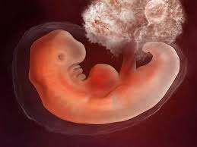

Fetus 24 weeks, image by labicentre.org

Further exploration of this concept of six limbs lead to a profound shift in my relationship with my body. I found myself playing with movement in a curious and childlike way, surprising myself at the simplicity of creating dynamic stretches that were specific to my own body patterns... I could lengthen and stretch my own muscles in a way that no one else could. My overall strength was also improving, in short the more I crawled; rolled and played about on the floor the better my body began to feel.

The Scientific Benefits of Developmental Movement
My experience then ignited some background reading into the science of developmental movement patterns that shows:

Crawling activates and integrates the different parts of the brain, improving neural pathway connections and enabling better communications between the left and right hemispheres.

Crawling unites your sensory systems. It integrates your vestibular system (your balance system), your proprioceptive system (your sense of self in space, or your self awareness system), and your visual system (your visual system). It can even improve your hand eye coordination.

Crawling builds a foundation of receptive strength, the original strength you were born to develop. Your reflexive strength, also known as your reflexive stability, is your body's ability to anticipate movement before it happens and/or reflexively react to movement as it happens.

Crawling resets and restores the central nervous system. It restores your central nervous system, lowers your stress levels, and allows you to recover faster from the rigors of your training or your day-to-day life.

The Physiology of Crawling
To better understand the physiology of crawling it helps to picture the body as a great big x.

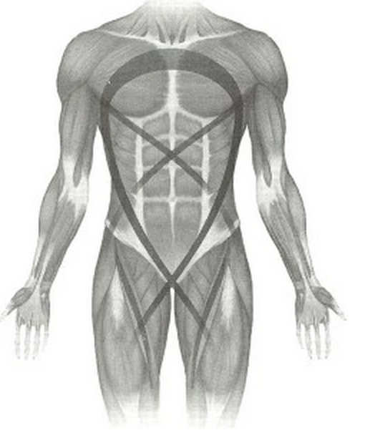

“It is in the center of your "X" that your body transfers the forces that you generate from one side to the other, from the bottom of you to the top of you. In other words, the center of your body is where the powerful forces you generate intersect and cross over. The more solid your center, the better the forces that you generate, or forces that you encounter, can be transferred. If your center is not solid, those forces could end up going into areas you don't want them to go and this could lead to injury. The more solid your "X,” the more resilient and capable you are. Having your reflexive strength is having a solid center, and having a solid center is having a body that is strong and mobile - a body without limits.”²

“As we explore, we find that the body is full of layer upon layer of extraordinary, ancient, ancestral power – four billion years of adaptation and embodied knowledge – and we start to anchor this understanding of shared ancestry and vast evolutionary timescales in the actual feeling of the body itself.”⁴

If you have mobility restrictions, nagging pains and injuries, if you feel fragile at times, it may be simply because you are lacking your reflexive strength - your original strength.

Crawling will gradually change the body maps and spacial maps of your brain, helping you restore original strength and allow you to improve your life in many areas. These improvements may include, physical strength, increased mobility, improved mental focus, improved stress response and better moods.

You may also notice that you begin to gain more conscious influence over the activities of the endocrine and immune systems as you improve the ability to change the focus of your awareness from the very small details inside your body to the infinitely large outside world.⁵

“How could we possibly forget such a basic human movement? The answer is easy; a lack of creative and exploratory physical movement in our every day lives. Use it or lose it!”
Ryan Ford Parkcor coach⁴

I wholeheartedly recommend crawling to my clients! And invite you to share a crawl with me at the Chiropractic Centre Bristol.

Reference list:
- Alice Cummins http://www.alicecummins.com
- Tim Anderson http://breakingmuscle.com/coaches/tim-anderson
- Simon Thakur http://ancestralmovement.co
- Ryan Ford Parkour coach – Crawl like a Baby: 5 Reasons to add quadrupedal movement to your workout. http://apexmovement.com/blog/crawl-like-a-baby-5-reasons-to-add-quadrupedal-movement-to-your-workout/

