Jump UP China – 17th to 19th March 2017

Executive Summary
The Jump Up program is growing from strength to strength in China.
Recent activities include:

- Translation of the program materials to Chinese by HuaTao group members – June to Dec 2016
- Delivery of a four-week pilot at the DongBeiYuCai Elementary School in Shenyang - December 2016 (lead facilitator Becky Zheng)
- International Facilitator training program (40 participants) – Beijing 17th to 19th March 2017 (lead facilitator Helena Read, translator Becky Zheng, hosts HuaTao Group, sponsors IDEAS group, TPA global representatives Maisa Aris and Mary Klug)
- Donation income from International Facilitator Training program $815.00 AUD / 4,831.00 Chinese Yuan (paid as cash to Helena Read and subsequently to Jump Up Account)

Current and proposed activities arising from Beijing training:

- Implementation of program within IDEAS camp programs, currently this includes adaptation of the Evolution of Earth activity.
- Trial programs in 4 – 6 schools by HuaTao group members in Shenyang (Summer 2017)
- International facilitator training programs to be hosted in Beijing, Shenyang and Changsha (Spring 2018)
- Development of training leader program (Pilot - Spring 2018)
- HuaTao group to secure sponsorship and funding for 2018 training programs

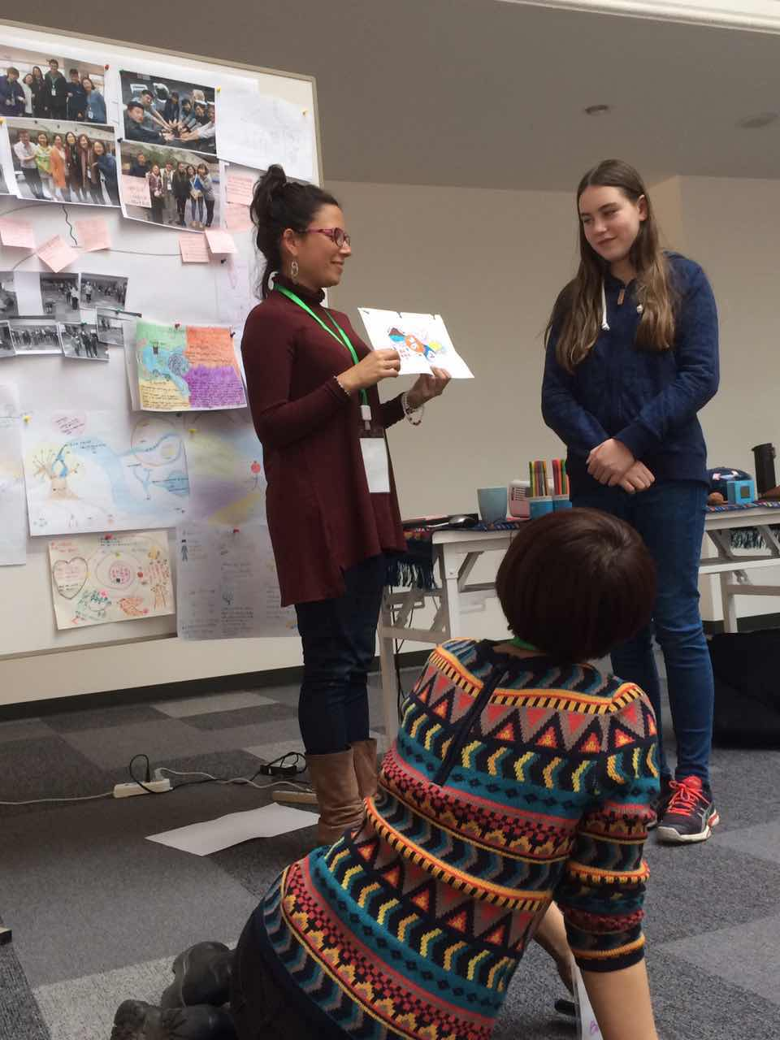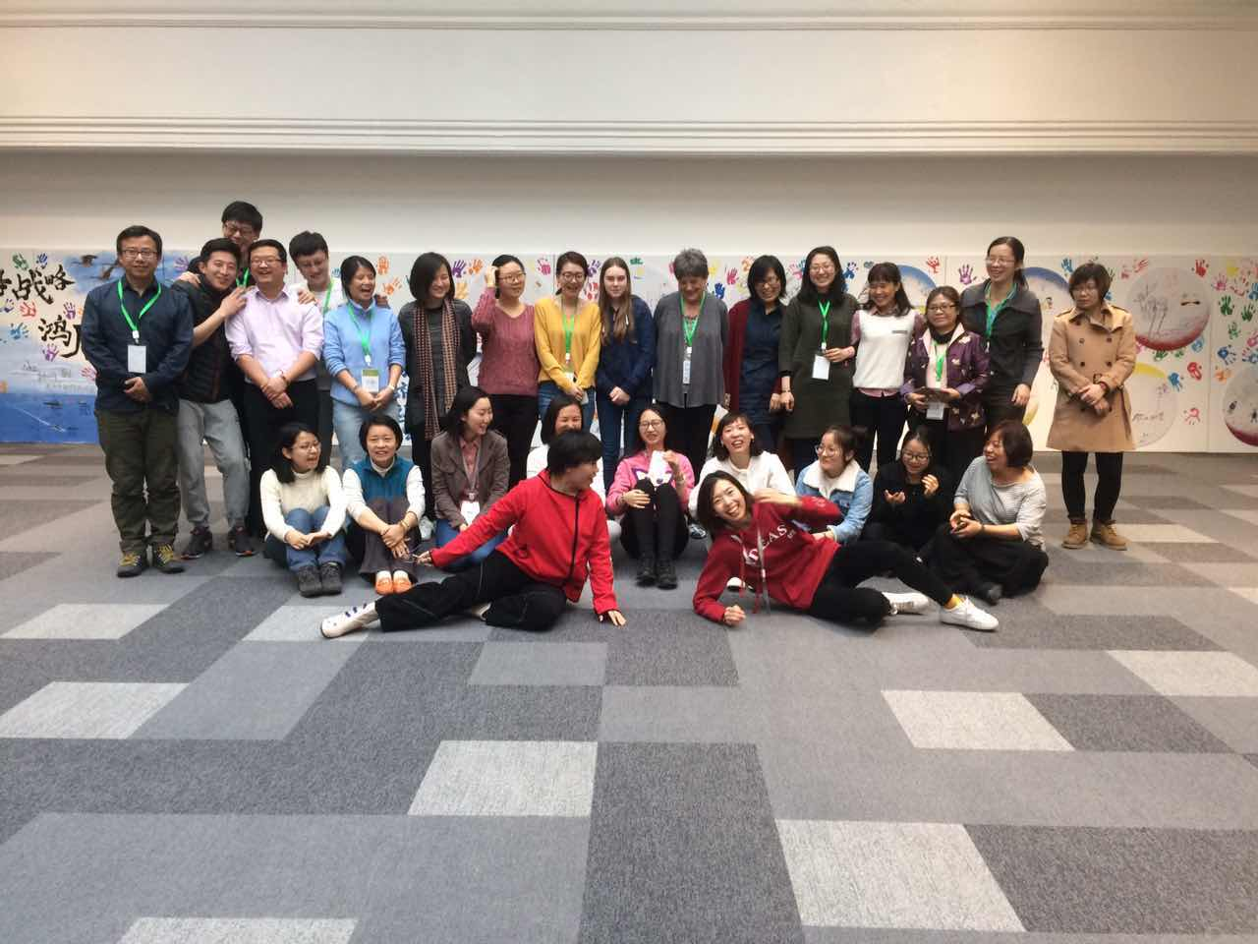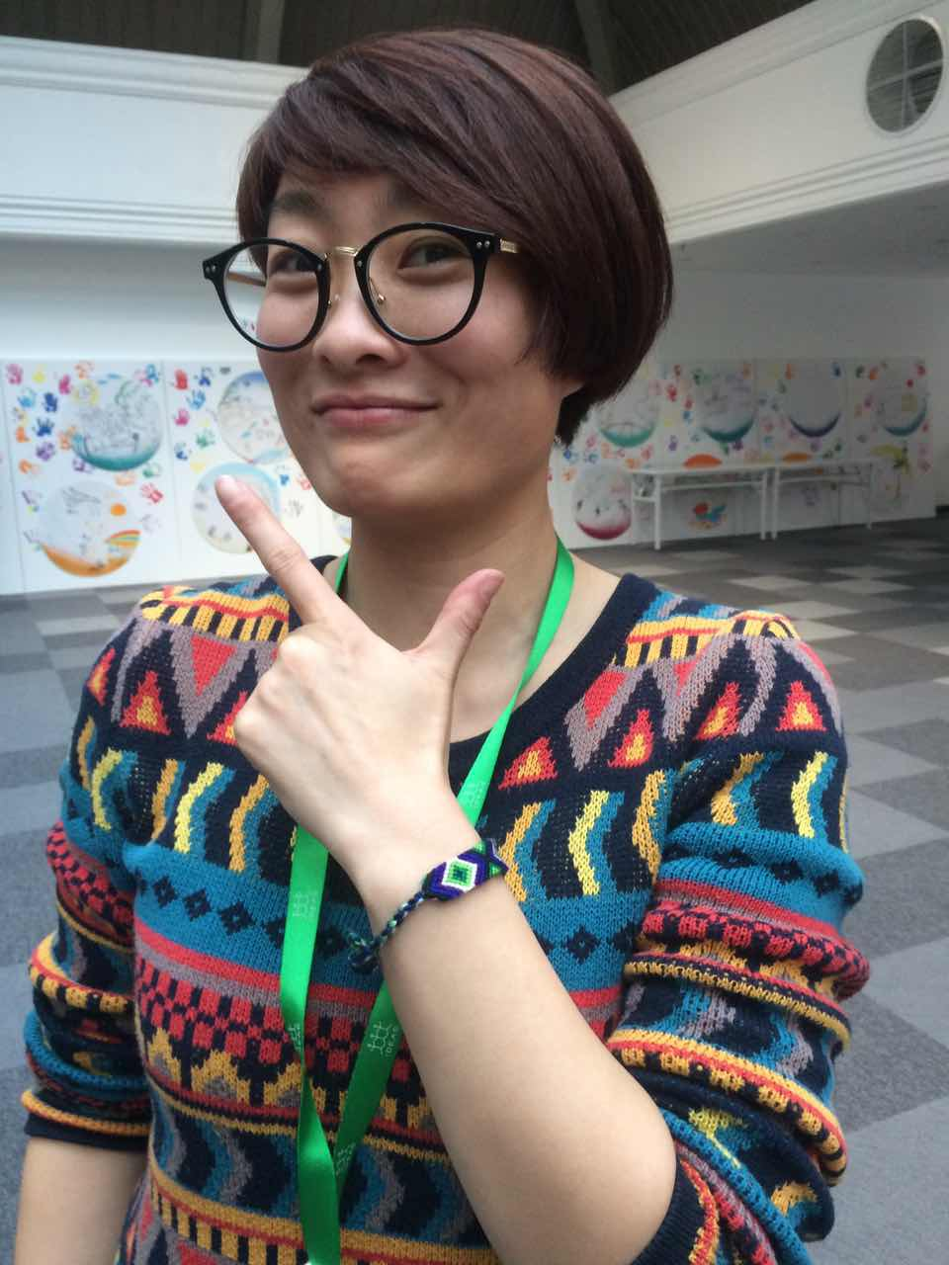

Directors Report
Astrologers and psychologists agree that our lives are profoundly influenced by 7-year cycles and the same appears to be true of the Jump Up Program. October 2017 will see the 7th Birthday of Jump Up, and wow is this becoming an exciting year!

From its inception in Australia in 2010 the program has been rigorously developed, it was toddling into a fully-fledged trial in 2012, began running with a facilitator training program in 2014 and was set free to the world via the creative commons in 2015.

Now, Jump Up has found its feet in China.

Thanks to the persistent promotions and careful nurturing of Maisa Aris - Pachamama Alliance Global Coordinator, the HuaTao group picked up the Jump Up program in late 2016. Almost immediately an amazing team of women set about translating the program into Chinese and by December 2016 the program was being run by entrepreneur extraordinaire Becky Zheng at the DongBeiYuCai Elementary School in Shenyang.

Becky’s words in an email to me in early January 2017 took on a life of their own:

“I am so touched by the children who attend the class... attached I’m sending you some of their feedback, its a really big surprise to me, the drawings, the questions, the imaginations... Children are really amazing!! I think Jump Up program is a gift to all children. Wish you could come to China sometime, really looking forward to sharing the great experience with you.”

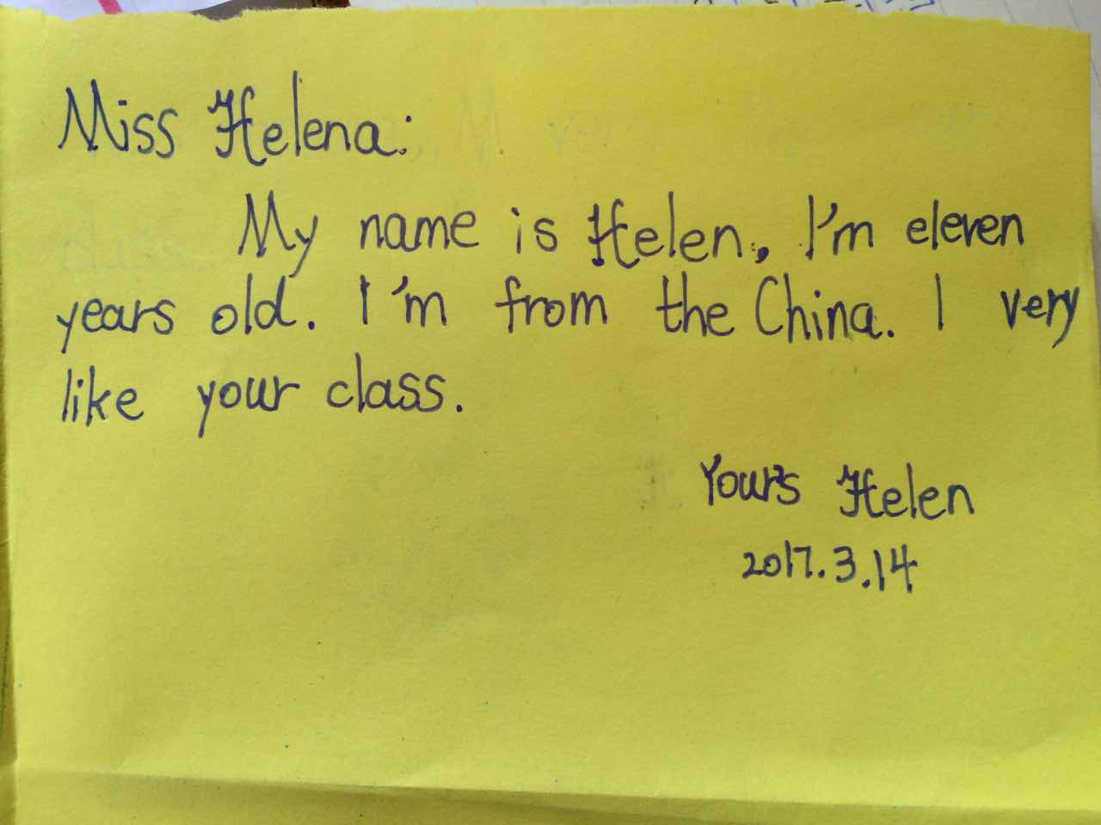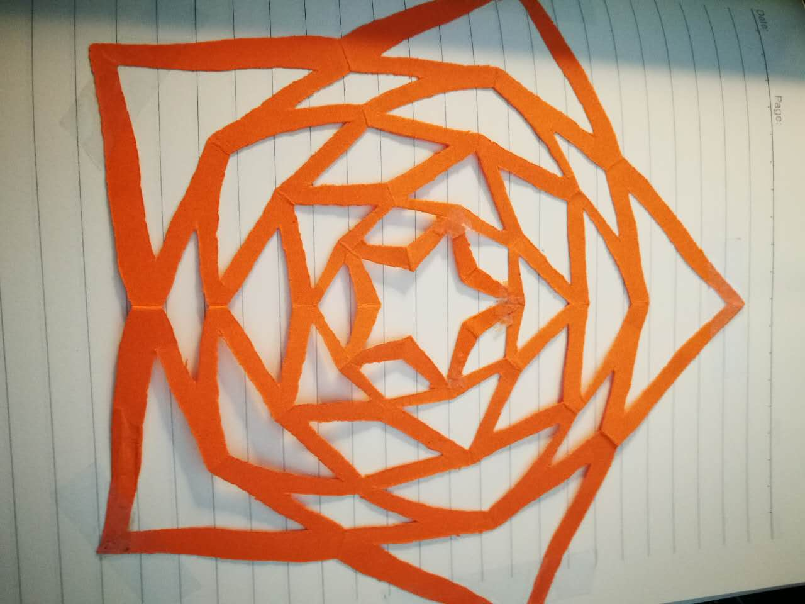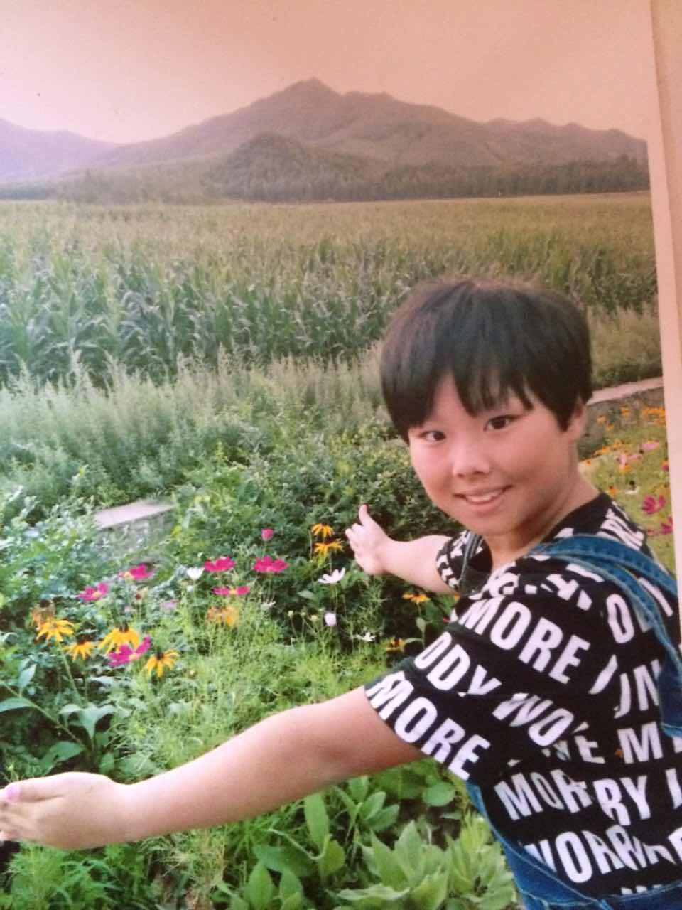

By mid January conversations were flying between China and the UK as the HuaTao group and I began hatching the first International facilitator-training program in Beijing. I happened to be in the throws of booking family flights to Australia, and China happens to be on the way... In hindsight I wonder is there ever such a thing as happenstance? I think Pachamama had a hand in assisting us all!

Delivering training in China became a rapidly viable proposition, IDEAS camp soon became our major sponsor, the venue was confirmed, dates advertised and within a matter of weeks we had 40 people from three provinces and the USA enrolled on the training.

Less than 8 weeks had passed since Becky’s serendipitous email, when my children and I arrived in Beijing at 4am on 15th March. We were met by our host Yuting Gao, who even brought hot sweet tea to the airport for us – what a quick way to win an Englishwoman’s heart! Yutings attentive hospitality and unwavering ability to respond to every request continued to amaze me throughout the following week.

Within 24 hours, our jet lag had sufficiently past, our cultural immersion had commenced via the wonderful tradition of ‘hot pot’ and we were meeting for the first time in person as a training team with Becky, Xiao Yang, Yuting, and Mary Klug (the remaining team members Amy, Silver and Maisa were to join us later)

Immediately any doubts I may have had about our ability to work effectively together to deliver a world-class training were put to rest... This was my first time as the soul-training leader, and certainly my first time delivering training to 40 people. However I was in the company of dedicated, skilled and passionate change agents, with highly professional outlooks and open hearts – a tribute to the power and effectiveness of the ATD programs, and wow, what a team! As the co-founder and director of Jump Up I was quietly confident that our training program and my abilities would be sufficient... I had to believe this, or I would have run a mile!!! We revised the training flow, adapted timeframes, checked resources, confirmed housekeeping, clarified our intentions, set the training room and turned in for an early night.

What followed was a fabulous three-day training, based closely on the training flow developed by the JU team in Australia, with simplified language to allow for translation and the time that translation commands.

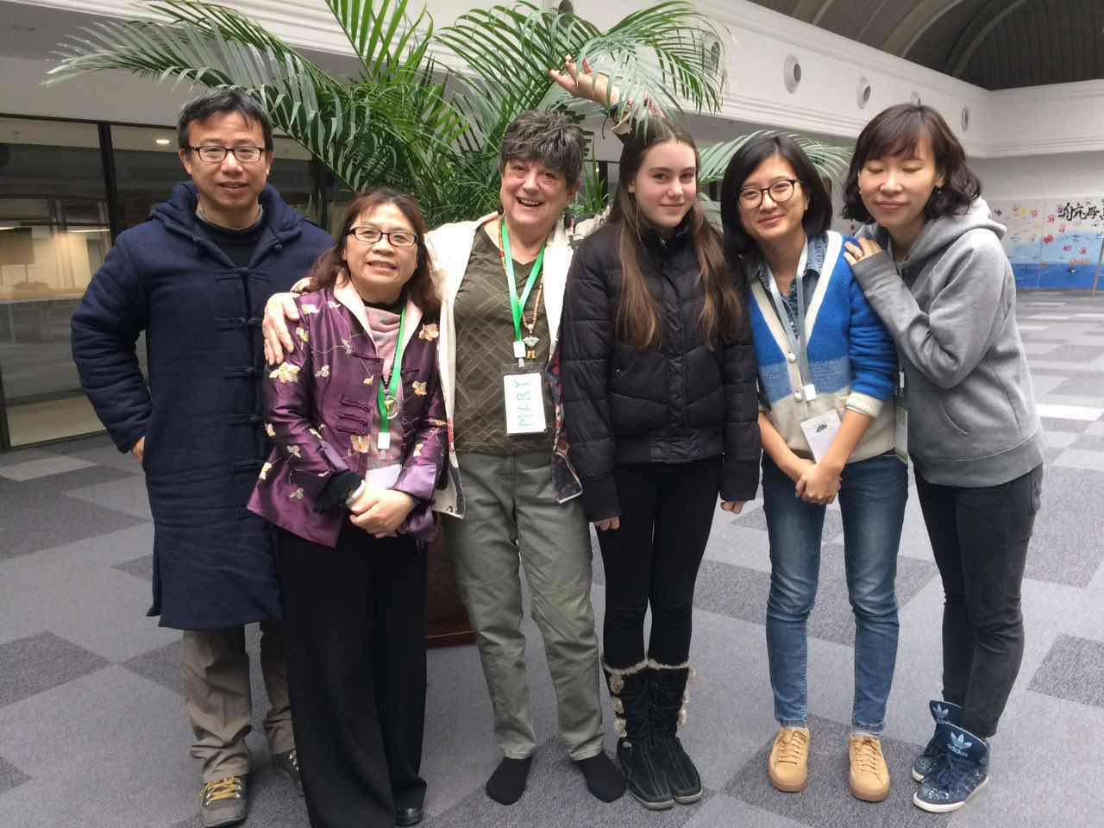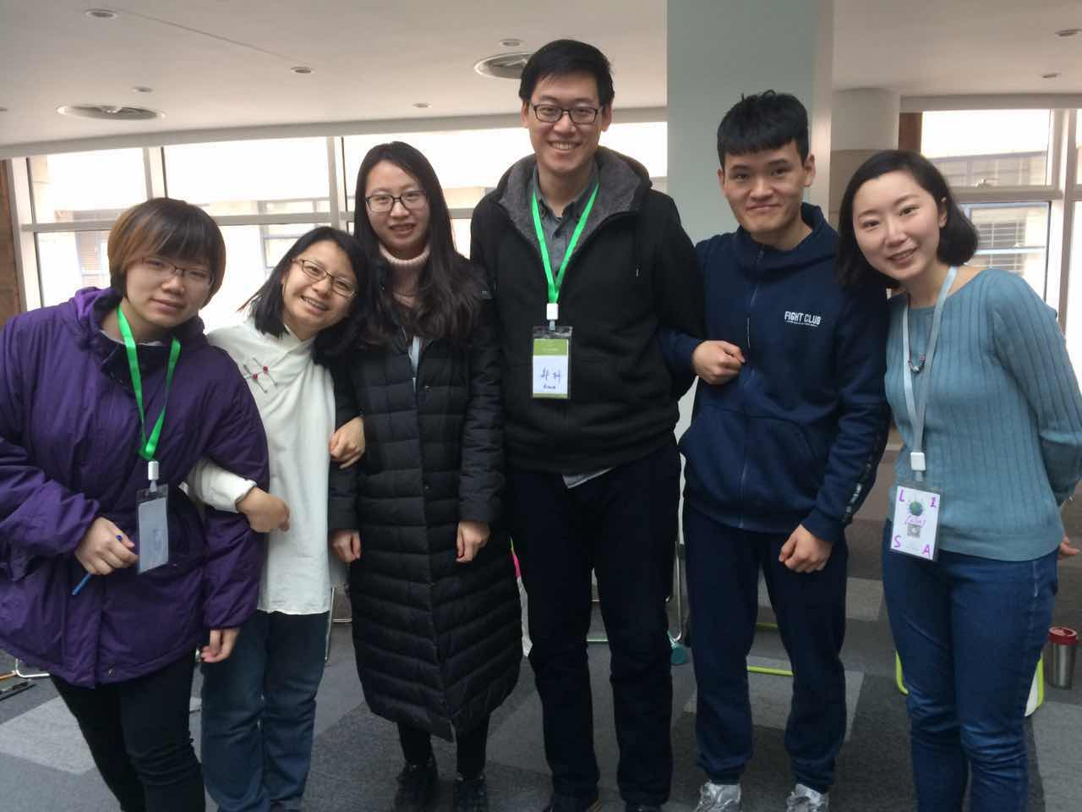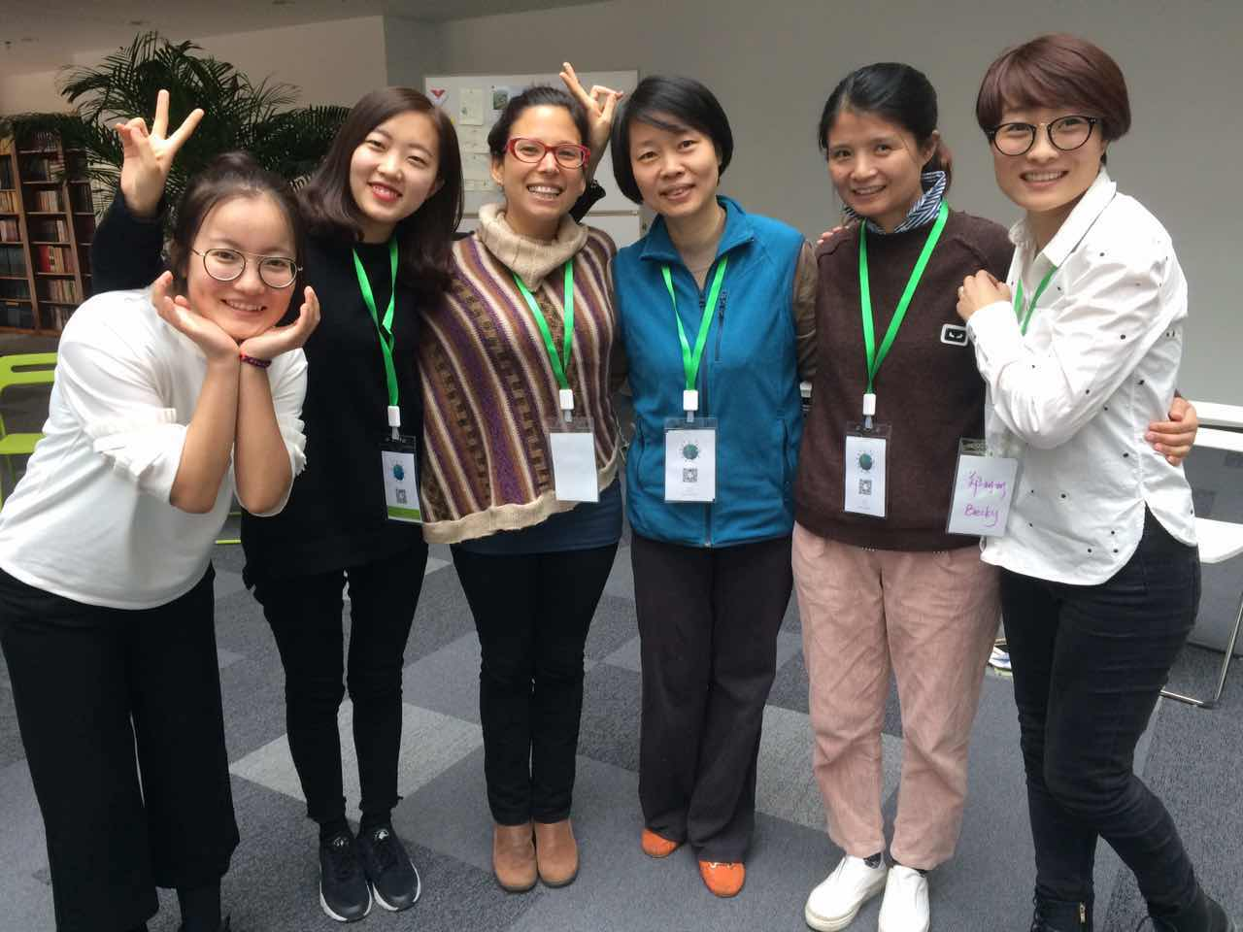
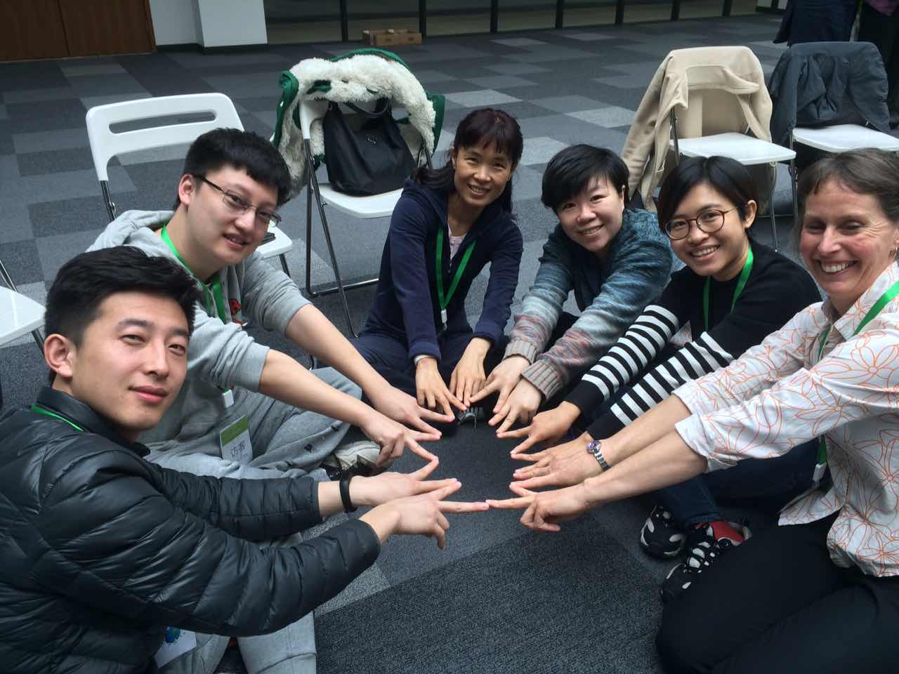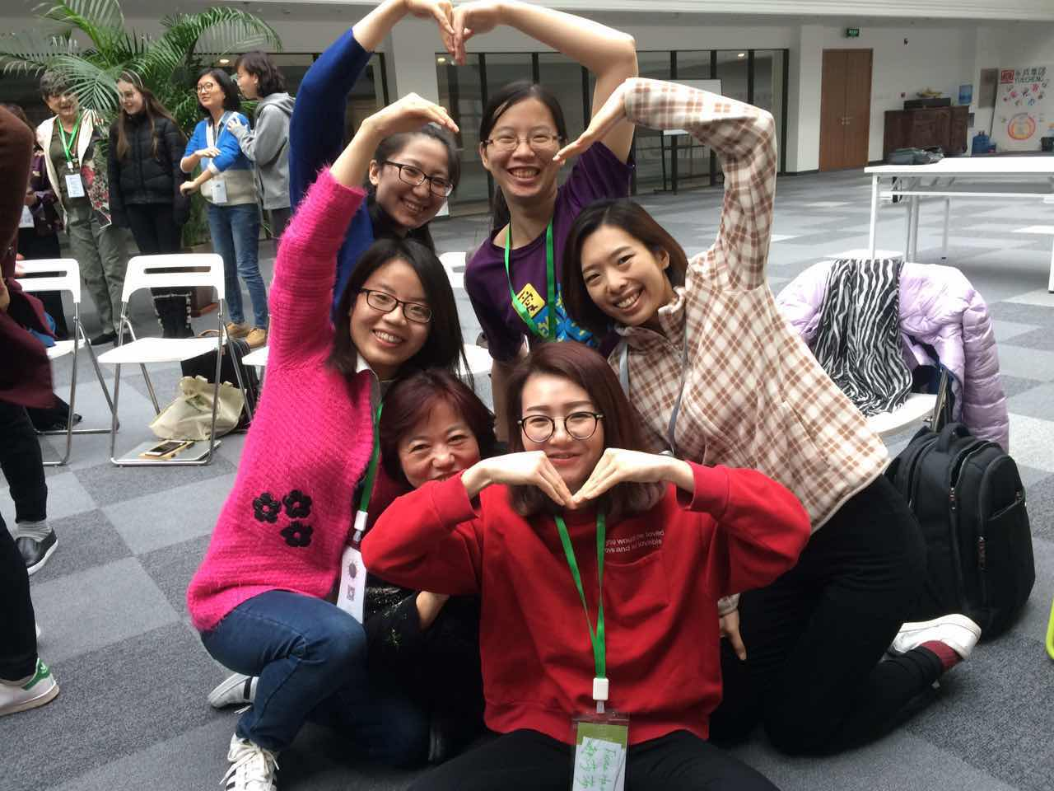

Our participants included staff councilors from the IDEAS Camp www.ideas-campoverseas.net Chinas leading camp organisation; members of the HuaTao group from Beijing, Chengdu and Changsha; Maisa Aris the TPA global coordinator; Mary Klug, founder of ATD in China; Harry Pan the founder of Chinas first Waldolf Steiner School; a lawyer and a publisher.

Feedback from the training was astounding.

- IDEAS camp will be implementing all areas of the Jump Up program to their camp programs in 2017 including activities, tools, assessments, matrix and curriculum. Their plan is to adapt the curriculum for their different camp groups, and they have already commenced this. Their request is that we (Pachamama Alliance, Ideas, Hautao and Australian JU team) design and deliver a JU leadership-training program for their staff in 2018.

- Huatao group intend to trial the program in 4 to 8 schools during the coming year, to develop their blossoming partnership with IDEAS and to host a JU training program and leadership training in Beijing, Chengdu and Changsha in 2018.

- Harry Pan intends to develop the JU curriculum as an 8-year curriculum for Waldolf Steiner schools.

- More general feedback included the affirmation that the Evolution of Earth activity is an impressive tool, which can (and should) be used with people of all ages and within the wider TPA facilitation tool kit.

- It was acknowledged that whereas the ATD training is focused on the manual and its use, the JU program includes extensive training on how we come to know our role as facilitators and change agents working specifically with children. Participants of the JU training must become grounded in both their participation as a student (ie, as if they are a child in their own class), and their knowledge as a facilitator delivering the program.

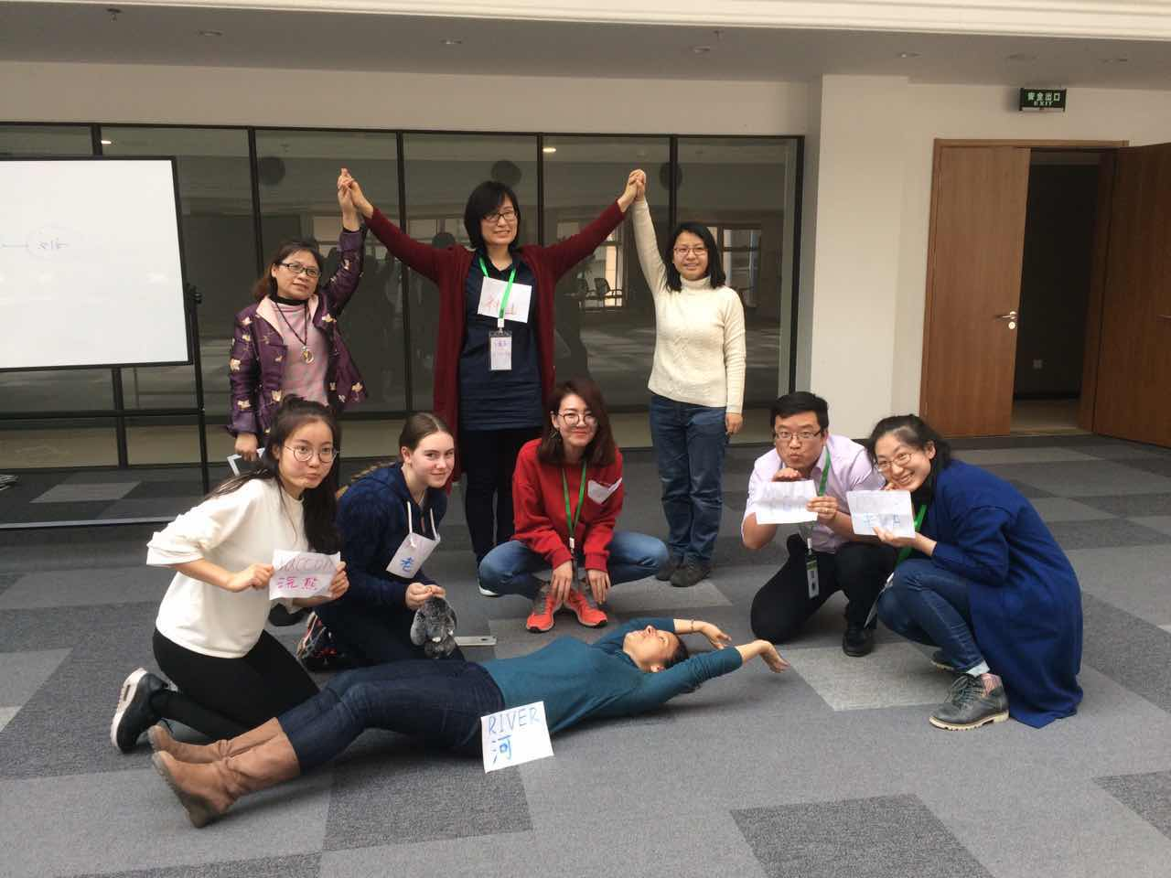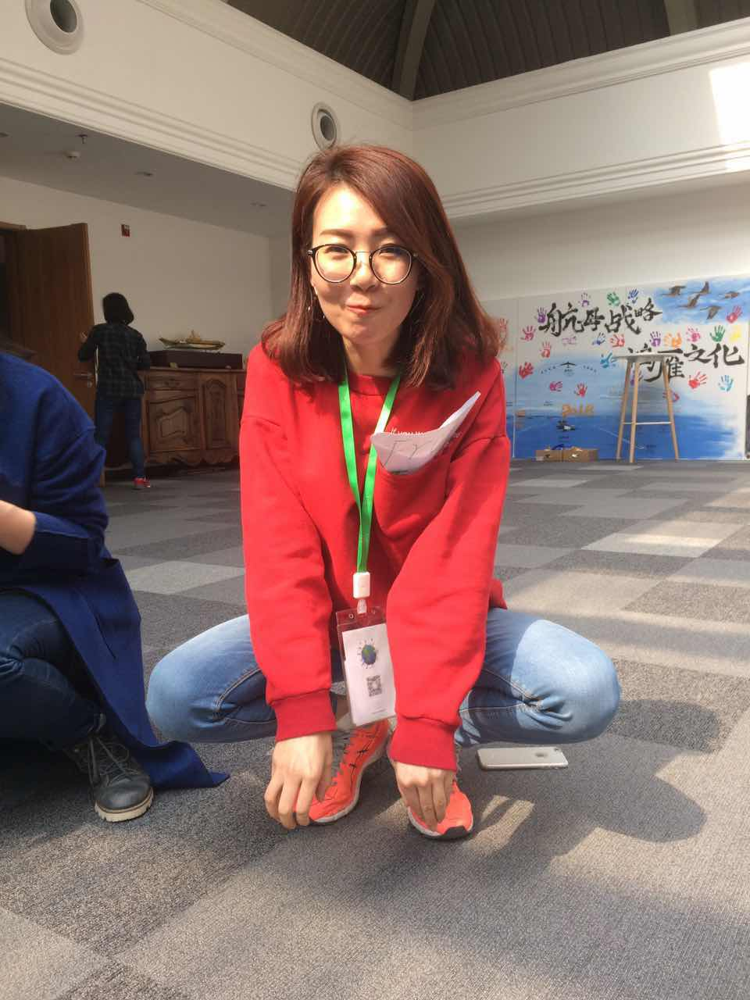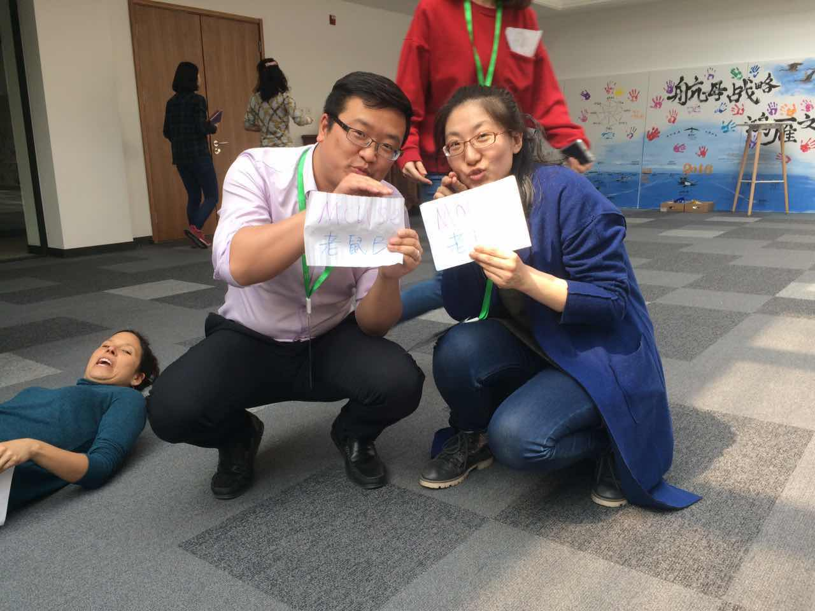

Areas to be developed for future trainings include:

- Careful reconsideration of the opening of sacred space in China. This can become easily and quickly associated with religion and dogma, so it is crucial to establish sacred space as part of a broader global context of social and political importance such as the stolen generation and current indigenous practices.

- Four day training with short days (9 – 4) to allow for reflection and personal study was proposed by HuaTao as the non-negotiable option for future trainings in China. By persistent request I crunched the training flow (being, knowing, doing) into three longer days (8.30 – 5.30) this compromised the depth of knowing.

- Jump Up Leadership training program To date this has not been developed, so funding and support will need to be secured to assist this development. If you are an existing JU facilitator or training leader, and would like to be involved in the development of THE JUMP UP LEADERSHIP PROGRAM please contact helena@helenaread.com or via We Chat.

Food for thought – An insight from JU China training for consideration by the wider ATD community:

The unexamined assumption of Beijing’s air pollution:

The most confronting challenge of working in Beijing for me was the intensely poor air quality. The pollution is literally thick enough to shade the midday sun, and this apparently was on a good day!

I asked our group what was the cause of such pollution and the response was simply ‘the cars’, yet when I looked at the cars on the busy city streets I could see no difference between the quantity or type of car being driven in Beijing than in any other modern city... So what was creating the difference?
When our group began to unpack this unexamined assumption we uncovered two contributing factors that have global implication for change agents.

- As the modern worlds primary producer of off shore manufacturing (Made in China) the environmental, social and wellbeing impacts upon China and its people are extensive. The real cost of cheap items that are manufactured in China for other countries is hidden from consumers and is paid by the Chinese people and their land.

- China is paid to dispose of large quantities of other countries garbage, this is predominantly plastic and it is predominantly burnt.

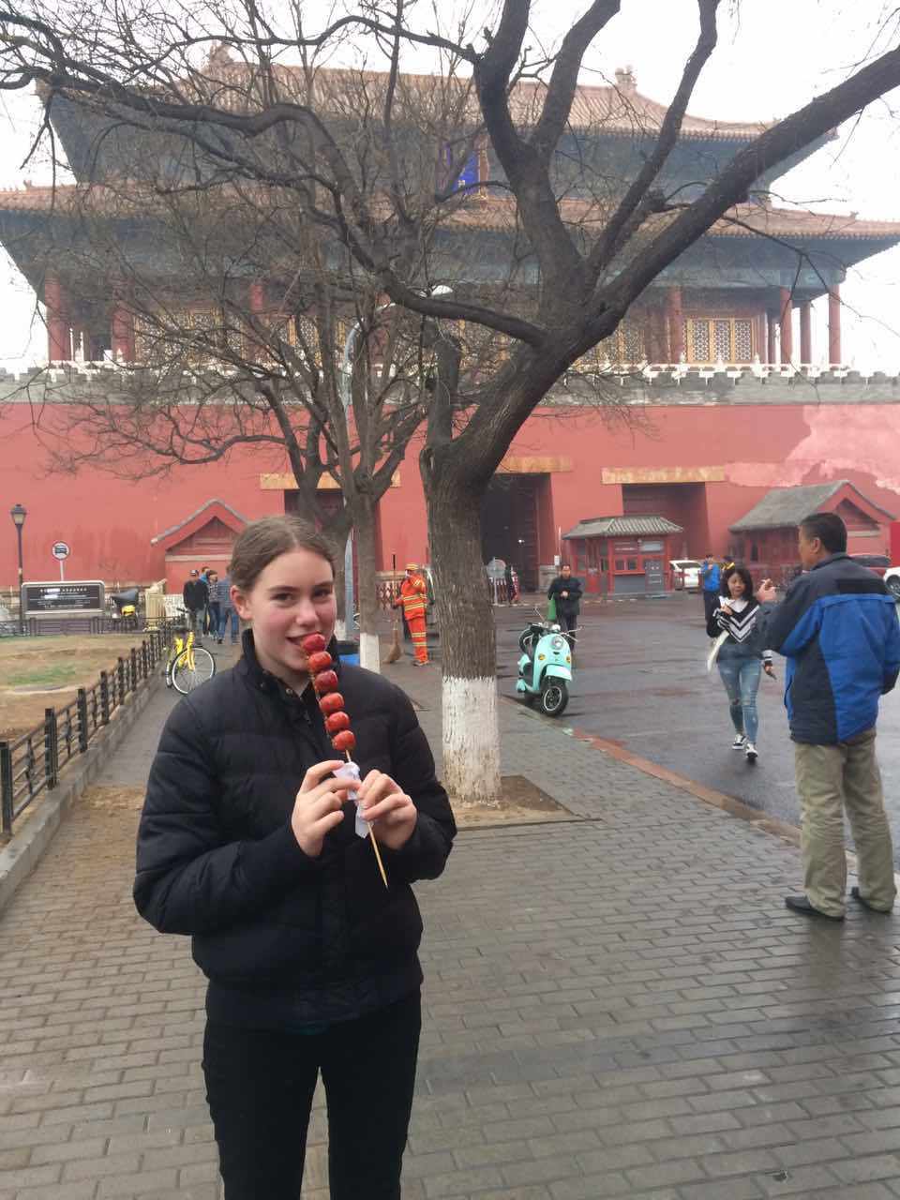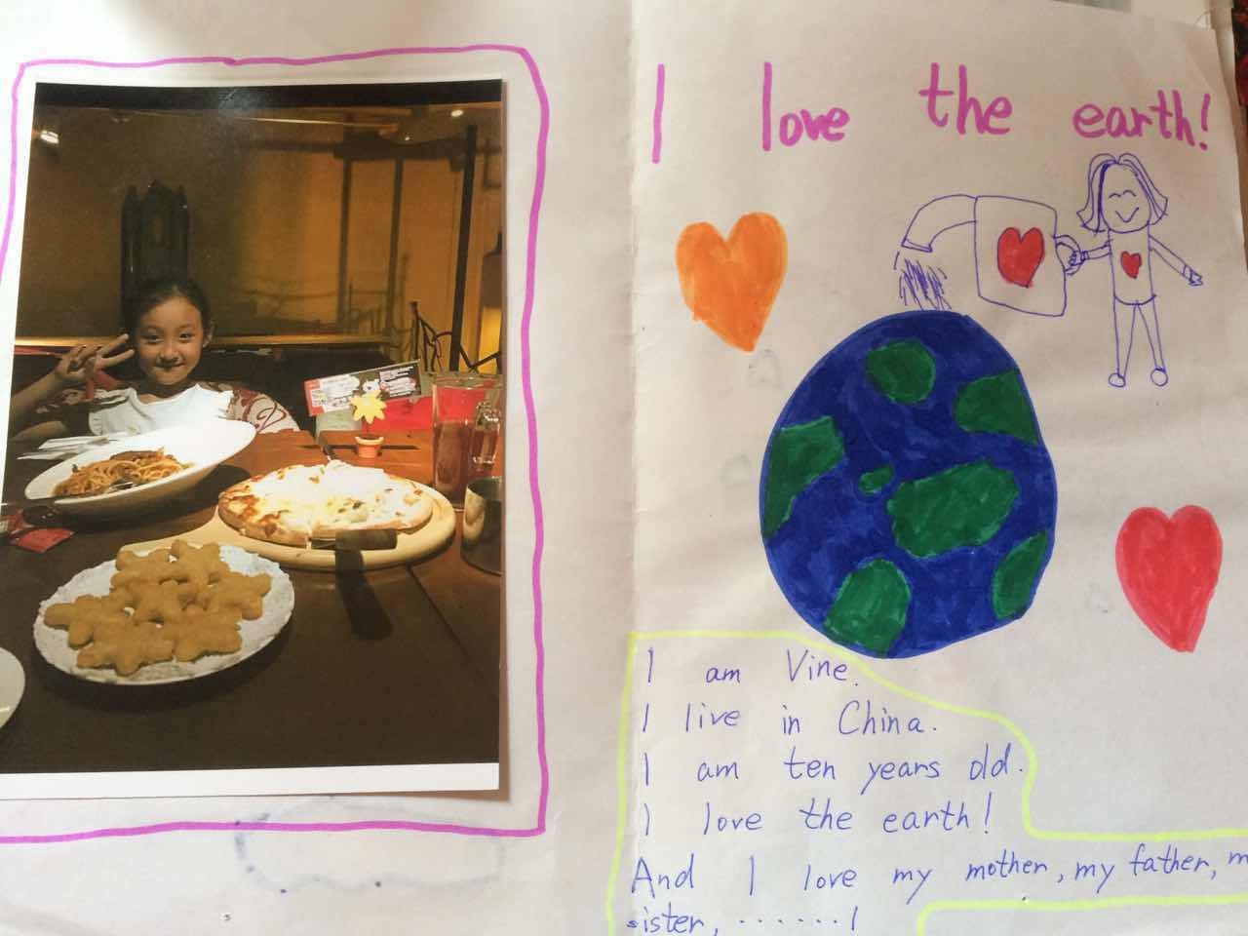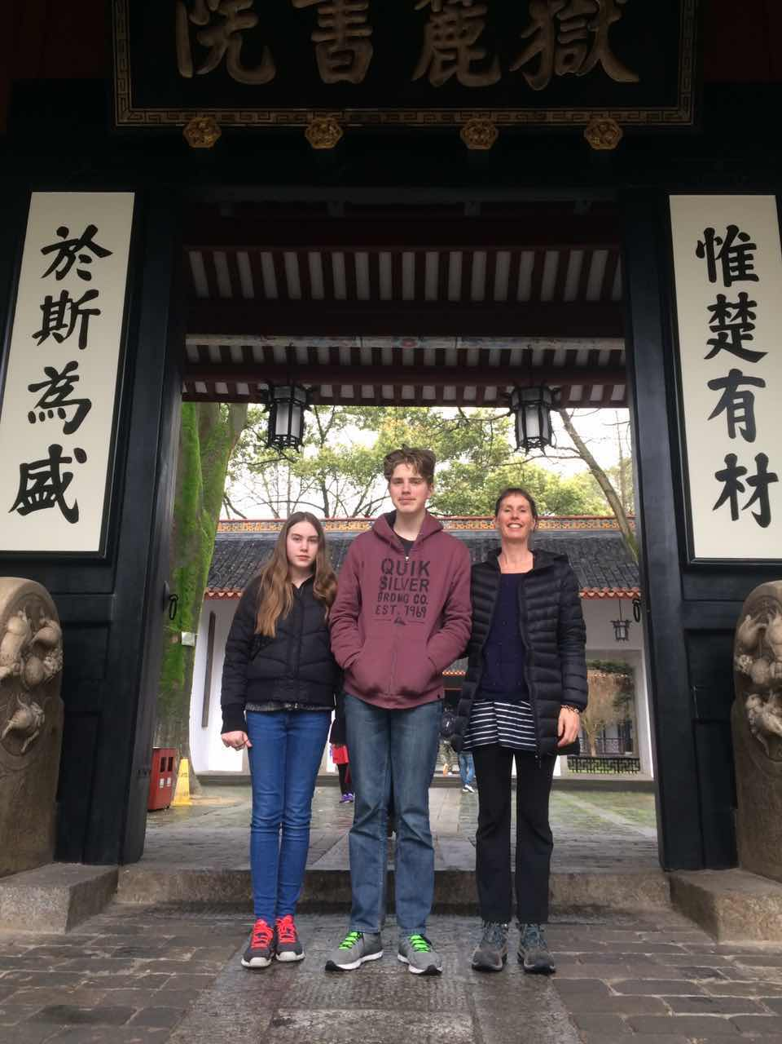

Profound thanks are due to the following people:
- HuaTao Group members Becky Zheng, Xiao Yang, Amy, Wendy Wu, Susan.
- Ideas hosts Lilly, Silver, Yuting Gao
- Pachamama Alliance representatives Maisa Aris, Mary Glug
- Lochie Read and Arwen Read MacCallum

